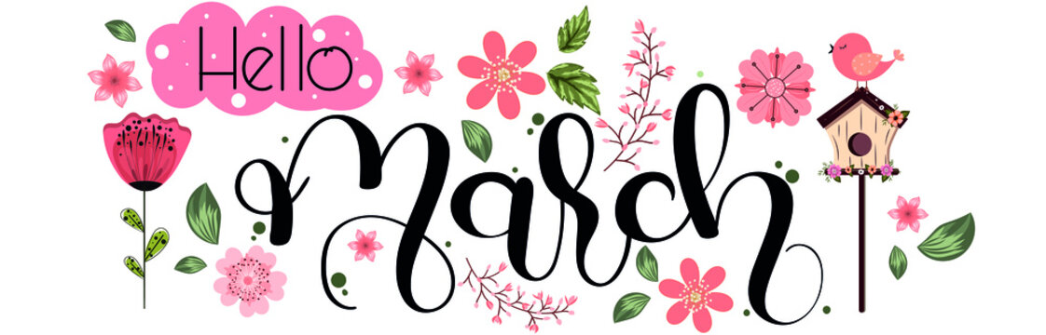
Nashua Public Library
March 2024
Library hours:
Monday, Tuesday, Wednesday 10:00 a.m. – 6:00 p.m.
Thursday 10:00 a.m. – 5:00 p.m.
Saturday 10:00 a.m. - 1:00 p.m.
Phone: 641-435-4635
You can reserve books online as well thru our online catalog, call the library if you need help:
https://nashua.biblionix.com/catalog/

Upcoming Events:
March 7, 2024- Coffee/ Tea & Conversation Senior Social Hour (every Thursday from 2-3 p.m.)
March 9, 2024- Children’s Spring Themed Program – 10:30 a.m. to 11:30 a.m.
March 13, 2024- Library Board Meeting – 7:00 p.m.
March 14, 2024- Coffee/ Tea & Conversation Senior Social Hour (every Thursday from 2-3 p.m.)
March 14, 2023- Chickasaw County Foot Clinic - 1 p.m. to 2:30 p.m. (must call the library to sign up)
March 21, 2024- Coffee/ Tea & Conversation Senior Social Hour (every Thursday from 2-3 p.m.)
March 28, 2024- Coffee/ Tea & Conversation Senior Social Hour (every Thursday from 2-3 p.m.)
March 30, 2024- “Bar” Crawl (Bar Recipe) Challenge – Contact the library for more information. 11 a.m.
April 8-13, 2024- National Library Week – Watch for more information on programs this week.
~~~~~~~~~~~~~~~~~~~~~~~~~~~~~~~~~~~~~~~~~~~~~~~~~~~~~~~~~~~~~~~~~~~~~~~~~~~~~~ Some of the new books we have at the library:
Last night By: Luanne Rice
The bad weather friend By: Dean Koontz
The women By: Kristin Hannah
The housemaids secret By: Freida McFadden
Never Lie By: Freida McFadden
15 ways to live longer and healthier By: Joel Osteen
The teacher By: Freida McFadden
The summer book club By: Susan Mallery
Crosshairs By: James Patterson
The ghost orchid By: Jonathan Kellerman
Chasing endless summers By: V.C. Andrews
4th wing By: Rebecca Yarros
Iron Flame By: Rebecca Yarros
Only if you’re lucky By: Stacy Willingham
The friendship club By: Robyn Carr
One in a million By: Janet Dailey
Random in death By: J.D. Robb
Harbor Lights By: James Lee Burke
Upside down By: Danielle Steel **Large Print**
Holmes, Marple & Poe By: James Patterson **Large Print**
Unnatural death By: Patricia Cornwell **Large Print**
Learned by heart By: Emma Donoghue **Large Print**
The manor house By: Gilly Macmillan **Large Print**
~~~~~~~~~~~~~~~~~~~~~~~~~~~~~~~~~~~~~~~~~~~~~~~~~~~~~~~~~~~~~~~~~~~~~~~~~~~~

