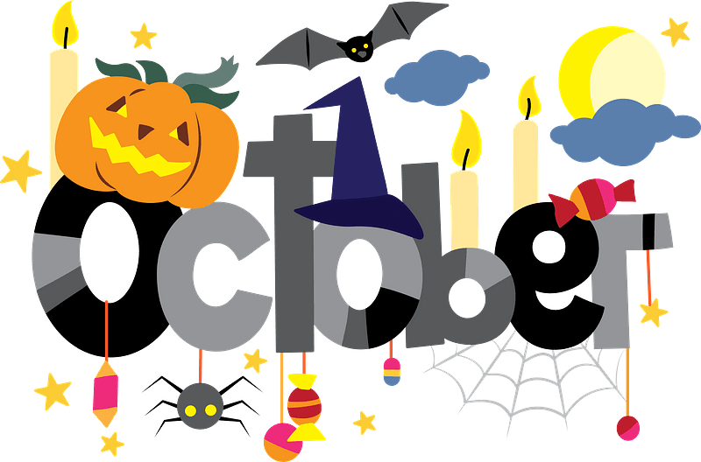
Nashua Public Library
October 2023
Library hours:
Monday, Tuesday, Wednesday 10:00 a.m. – 6:00 p.m.
Thursday 10:00 a.m. – 5:00 p.m.
Saturday 10:00 a.m. - 1:00 p.m.
Phone: 641-435-4635
You can reserve books online as well thru our online catalog, call the library if you need help:
https://nashua.biblionix.com/catalog/

Starting Monday, August 28, 2023 the library will offer Notary Services to patrons. Our library director is now a Notary Public thru the State of Iowa. If you need Notary Services, make sure to stop into the library or call to ensure our library director is available.

Upcoming Events:
October 2, 2023 – October 23, 2023- Book Pumpkin Character Contest. See library for details.
October 7, 2023- Magnolia “Maggie” Rivers Author Visit 10:30 a.m. – 11:30 a.m.
October 11, 2023- Chickasaw County Library Association Meeting – 6:30 p.m.
October 11, 2023- Library Board Meeting – 7:00 p.m.
October 18, 2023- LEGO Day at the library – 2:00 p.m. -4:00 p.m.
October 18, 2023- Meet & Greet - Nashua City Council Candidates – 6:30 p.m. – 7:30 p.m.
October 21, 2023- Lunch with Linda McCann (Rosie the Riveter book) 11 a.m. – Noon. Linda will be here to talk about her newest book about Rosie the Riveter. A light lunch will be served for those who attend.
October 18, 2023- Special - Meet & Greet - Nashua City Council Candidates – 12:00 p.m. – 1:00 p.m.
November 8, 2023- Library Board Meeting – 7:00 p.m.
November 9, 2023- CLOSED for Veteran’s Day
November 11, 2023- CLOSED for Veteran’s Day
November 15, 2023- LEGO Day at the library – 2:00 p.m. -4:00 p.m.
November 18, 2023- Lunch with Sheila Craig- Remembering the apron program- 10:30 a.m. – 11:30 p.m.
November 20, 2023- Pajama’s & Pancake Children’s Program- 5:30-6:30 p.m.
December 2, 2023- Santa’s Workshop at the library. More details to come.
~~~~~~~~~~~~~~~~~~~~~~~~~~~~~~~~~~~~~~~~~~~~~~~~~~~~~~~~~~~~~~~~~~~~~~~~~~~~~~ Some of the new books we have at the library:
Slow cookers, casseroles & skillets
Taste of Home Christmas 2023
Taste of Home Best Shared Recipes 2024
Things we left behind By: Lucy Score
Code Red By: Vince Flynn
Tom Clancy’s Weapons Grade By: Don Bentley
Payback in death By: J.D. Robb
23 ½ lies By: James Patterson
Talking to my angels By: Melissa Etheridge
The river we remember By: William Kent Kruger
The Breakaway By: Jennifer Weiner
Holly By: Steven King
Guinness World Records 2024
The traitor among us By: Anne Perry
Traitors Gate By: Jeffrey Archer
12 months to live By: James Patterson
Blessings of the lost girls By: J.A. Jance
Killing the witches By: Bill O’Reilly
Taste of Home Holiday & Celebrations
Celebrate the Season 2023– Better Homes & Gardens
Yellowstone Cookbook
Look out for the little guy By: Scott Lang
Gluten Free Christmas Cookbook
And there he kept her By: Joshua Moehling
The Starfish Sisters By: Barbara O’Neal
23 ½ Lies By: James Patterson **Large Print**
Happiness By: Danielle Steel **Large Print**
Lion & Lamb By: James Patterson **Large Print**
~~~~~~~~~~~~~~~~~~~~~~~~~~~~~~~~~~~~~~~~~~~~~~~~~~~~~~~~~~~~~~~~~~~~~~~~~~~~
New DVD’s & Blu-Ray’s:
The Wedding Veil - Inspiration (DVD)
Beverly Hills Wedding (DVD)
My Best Friend’s Bouquet (DVD)
Elemental (DVD)
Elemental (BLU-RAY)
~~~~~~~~~~~~~~~~~~~~~~~~~~~~~~~~~~~~~~~~~~~~~~~~~~~~~~~~~~~~~~~~~~~~~~~~~~~~
Memorials & Donations:
Monetary Donation in memory of Bill Kunzman By: Linda Moritz

