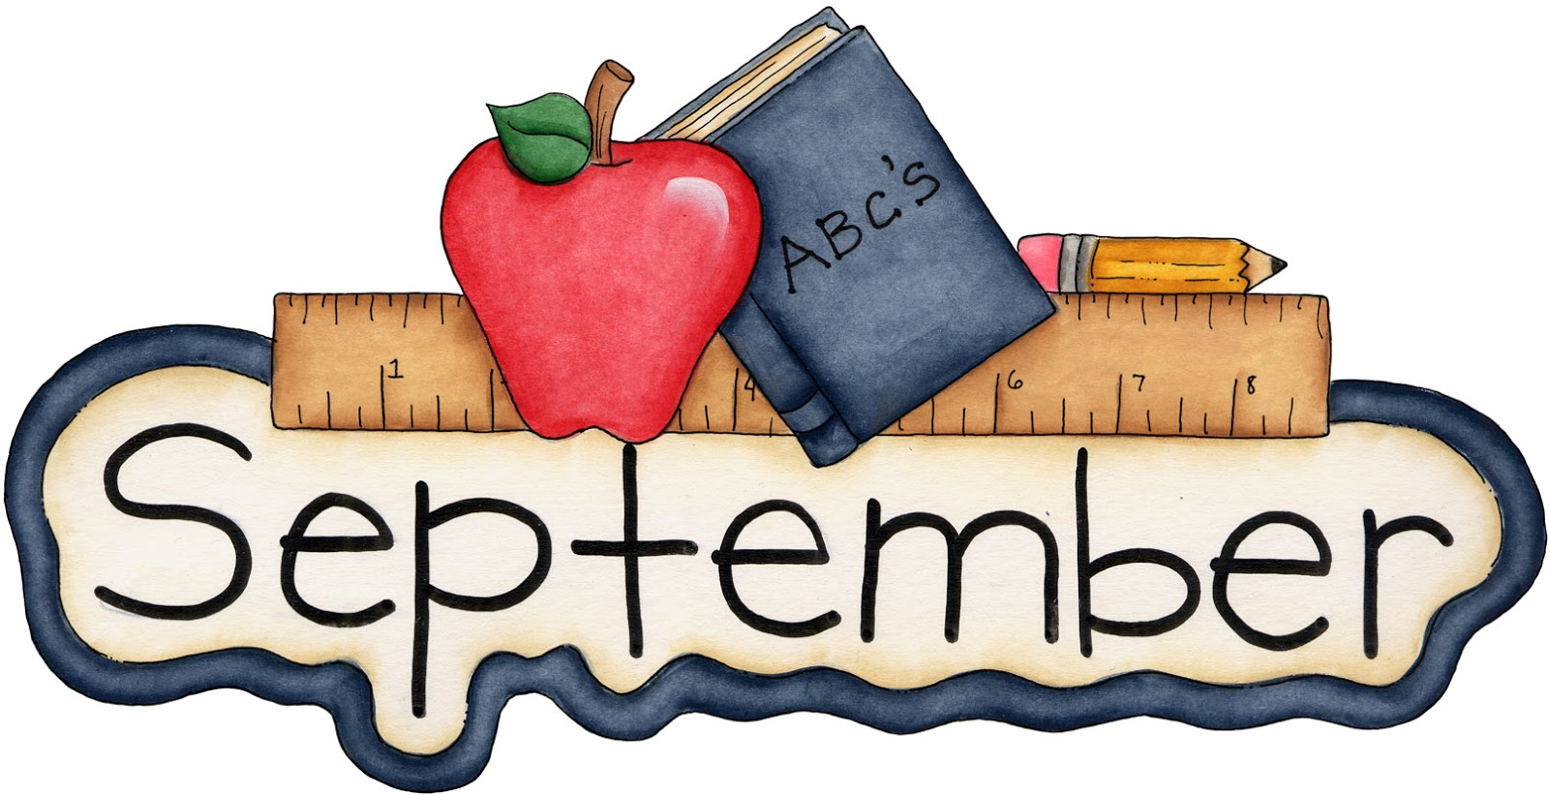
Nashua Public Library
September 2023
Library hours:
Monday, Tuesday, Wednesday 10:00 a.m. – 6:00 p.m.
Thursday 10:00 a.m. – 5:00 p.m.
Saturday 10:00 a.m. - 1:00 p.m.
Phone: 641-435-4635
You can reserve books online as well thru our online catalog, call the library if you need help:
https://nashua.biblionix.com/catalog/

Starting Monday, August 28, 2023 the library will offer Notary Services to patrons. Our library director is now a Notary Public thru the State of Iowa. If you need Notary Services, make sure to stop into the library or call to ensure our library director is available.

Upcoming Events:
September 2, 2023- “FALL” themed Children’s Program 10:30-11:30 a.m.
September 4, 2023- CLOSED in observance of Labor Day.
September 13, 2023- Library Board Meeting – 7p.m.
September 16, 2023- Movie Matinee – Book Club 2 – This is a PG-13 movie. Refreshments will be served. 10:30 a.m. – 12:30 p.m.
October 7, 2023- Magnolia “Maggie” Rivers Author Visit 10:30 a.m. – 11:30 a.m.
October 21, 2023- Lunch with Linda McCann (Rosie the Riveter book) 11 a.m. – Noon. Linda will be here to talk about her newest book about Rosie the Riveter. A light lunch will be served for those who attend.
~~~~~~~~~~~~~~~~~~~~~~~~~~~~~~~~~~~~~~~~~~~~~~~~~~~~~~~~~~~~~~~~~~~~~~~~~~~~~~ Some of the new books we have at the library:
None of this is true By: Lisa Jewell
The girls who fought crime By: Maj. Gen Mari Eder
The Bone Hacker By: Kathy Reichs
Out of nowhere By: Sandra Brown
Canary Girls By: Jennifer Chiaverini
Happiness By: Danielle Steel
Another Bundt Collection
Family Reins By: Billy Busch
The night agent By: Matthew Quirk
Rock Bottom By: Fern Michaels
Tides of fire by James Rollins
Lion & Lamb By: James Patterson
Kingdom Quarterback By: Mark Dent
The summer that made us By: Robyn Carr
Slammed By: Colleen Hoover
Point of Retreat By: Collen Hoover
This girl By: Colleen Hoover
Like a river By: Granger Smith
Obsessed By: James Patterson **Large Print**
The Collector By: Danielle Silva **Large Print**
~~~~~~~~~~~~~~~~~~~~~~~~~~~~~~~~~~~~~~~~~~~~~~~~~~~~~~~~~~~~~~~~~~~~~~~~~~~~
New DVD’s & Blu-Ray’s:
Fast X (DVD)
~~~~~~~~~~~~~~~~~~~~~~~~~~~~~~~~~~~~~~~~~~~~~~~~~~~~~~~~~~~~~~~~~~~~~~~~~~~~
Memorials & Donations:
Monetary Donation to the library for future programming By: Anonymous Donors
Monetary Donation in memory of Bill Kunzman By: Lucille Fober


