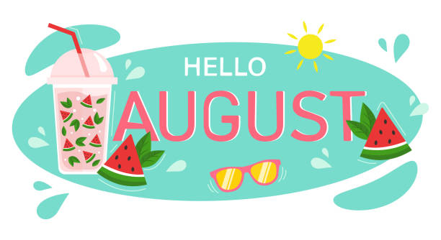
Nashua Public Library
August 2023
Library hours:
Monday, Tuesday, Wednesday 10:00 a.m. – 6:00 p.m.
Thursday 10:00 a.m. – 5:00 p.m.
Saturday 10:00 a.m. - 1:00 p.m.
Phone: 641-435-4635
You can reserve books online as well thru our online catalog, call the library if you need help:
https://nashua.biblionix.com/catalog/

Upcoming Events:
August 2, 2023- Find your voice thru laughter – Join us for a fun night with Absolute Science! They will be here with their Mega Foam Blaster! This is a dry stacking foam that evaporates for easy cleanup. It shoots out 40 feet and is non-slippery, non-toxic, non-staining, non-allergenic and is also bio-degradable. It is fun for all ages, as well as the environment. Come dressed in something you don’t mind getting full of foam! Run, jump, laugh and have fun in this exciting program to end the summer program!
August 9, 2023- Library Board Meeting @ 7 p.m.
August 19, 2023- National Mississippi River Museum & Aquarium - 10:30-11:30 a.m. (Dive into the amazing world of ocean creatures with the Mississippi River Traveling Touch Tank!) Pre-Registration Required: Limit of 100 participants! Sign up will be available starting August 1, 2023. You must have a ticket to guarantee a spot / and be able to do the touch tank! SIGN UP ONLY AT THE LIBRARY IN PERSON! Tickets will be given out when you sign up at the library in person! And you MUST have a ticket to get into the library during the program.
August 30, 2023- Adult Painting Workshop – Mini Barn Quilt Painting. 5:00-6:30 p.m. **Must sign up to be included in this workshop. **
September 4, 2023- CLOSED in observance of Labor Day.
September 16, 2023- Lunch with Linda McCann (Rosie the Riveter book) 11 a.m. – Noon. Linda will be here to talk about her newest book about Rosie the Riveter. A light lunch will be served for those who attend.
~~~~~~~~~~~~~~~~~~~~~~~~~~~~~~~~~~~~~~~~~~~~~~~~~~~~~~~~~~~~~~~~~~~~~~~~~~~~~~ Some of the new books we have at the library:
The last ride of the Pony Express By: Will Grant
Famous in a small town By: Viola Shipman
All the days of summer By: Nancy Thayer
Obsessed By: James Patterson
Palazzo By: Danielle Steel
Must love flowers By: Debbie Macomber
The Missus By: E.L. James
2023 Christmas with Southern Living
Family Handyman- Best Tips & Projects
Too Late By: Colleen Hoover
Midwest State Park Adventures
The Zoo Crew Series of 6 books By: Dustin Stevens
Hello Stranger By: Katherine Center
Secrets in the dark by Heather Graham
The summer skies By: Jenny Colgan
After Death By: Dean Koontz
The Bourne Defiance By: Brian Freeman
The Collector By: Daniel Silva
Private Moscow By: James Patterson **Large Print**
The 5 Star Weekend By: Elin Hilderbrand **Large Print**
~~~~~~~~~~~~~~~~~~~~~~~~~~~~~~~~~~~~~~~~~~~~~~~~~~~~~~~~~~~~~~~~~~~~~~~~~~~~
New DVD’s & Blu-Ray’s:
A man called Otto (DVD)
Yellowstone- Season 5: Part 1 (DVD)
The Wedding Veil (DVD)
The Wedding Veil Legacy (DVD)
The Wedding Veil Unveiled (DVD)
The Wedding Veil Expectations (DVD)
The Super Mario Brothers (DVD)
The Super Mario Brothers (BLU-RAY)
Avatar: The way of water (DVD)
Avatar: The way of water (BLU-RAY)
Book Club: The Next Chapter (DVD)
~~~~~~~~~~~~~~~~~~~~~~~~~~~~~~~~~~~~~~~~~~~~~~~~~~~~~~~~~~~~~~~~~~~~~~~~~~~~
Memorials & Donations:
Monetary Donation to the library By: David & Christine Skilton


